Protect Your Home: Think Like a Burglar

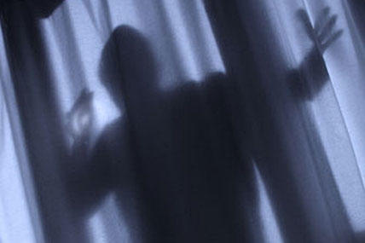

USAA

Burglars tend to look for the easiest targets. By keeping your home secure and making it tougher to access, you increase the odds that thieves will go elsewhere. The Insurance Information Institute says you can make your home less burglar-friendly with a few easy steps.
- Do a walk-around of your house, thinking like a burglar. Focus on entry points such as doors and windows, and think about ways to make them more secure.
- Look for areas where a burglar might be able to hide, such as behind large shrubs or trees near the home. Trim landscaping around the house to give thieves less cover.
- Thieves love working in the dark. Make sure you have plenty of exterior lights, including motion-activated systems.
- Don't underestimate simple but effective items such as padlocks and window bars or grates. Anything that slows a would-be thief will make him more likely to give up.
- Invest in a security system — ideally, one that has an off-site monitoring system that will be alerted if a possible security breach occurs at your home.
- Avoid displaying collectibles or other valuable items where they are easily visible from the street, as this may make it tough for a thief to resist.
Also, if you are planning to be away, arrange to have your home look lived in and avoid doing or saying anything that might inadvertently let others know your home will be unattended
ASK YOURSELF: If I were a burglar, which home on your street would you hit?

