Home Security Countermeasures to Keep Your Home and Family Safe

There are lots of things we can do to make our homes seem uninviting to criminals. The more difficult your property it is to breach, the more likely it is that would-be thieves will select an easier target.

- Secure Your Doors with Multiple Locking Mechanisms

Yes, it is an annoyance to carry multiple keys but why make it easy for the bad guys? A deadbolt is essential and even two would not be excessive.

Make sure the locks are difficult to pick.

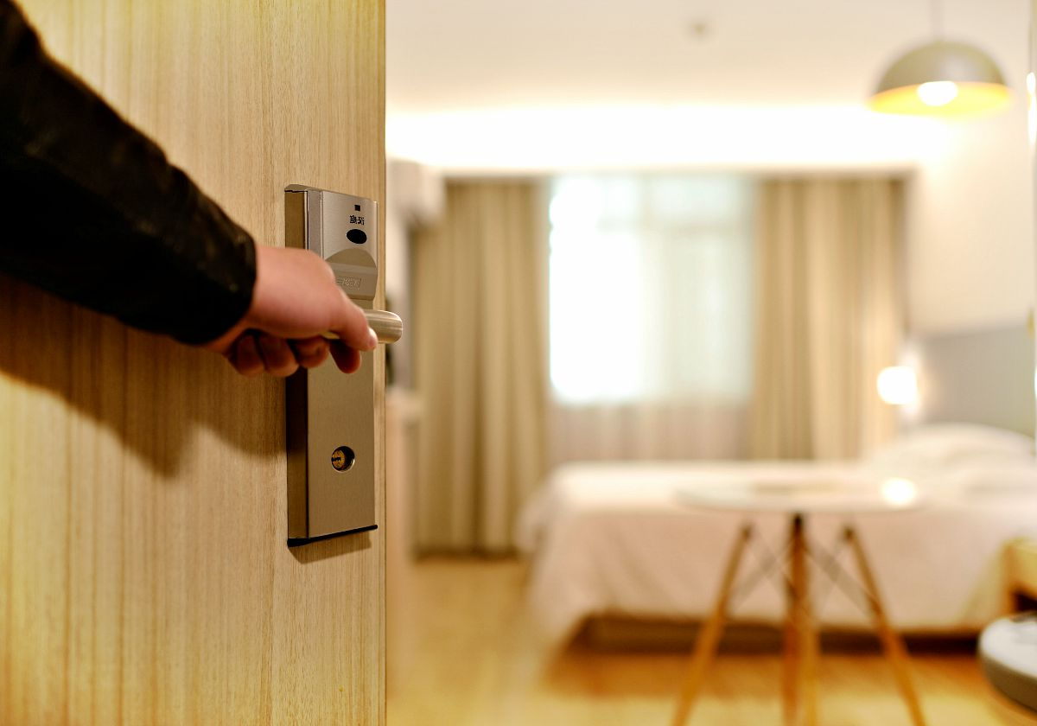

- Reinforce Your Door Frame

Remember that a lock is only as good as the strength of the door frame. It doesn’t matter how many locks you have if they are only supported by a flimsy interior frame. A strong person can generally break those down with a well-placed hit from a shoulder. Invest in a high-quality metal frame. These are very difficult to breach.

- Do Not Leave Keys Out

Even if you think you’re being clever, don’t leave keys under mats, under flower pots, on top or door frames, or in one of those $3 magnetic key carriers that fit under the frame of your car. Thieves know about these places and are more creative than you might think when it comes to locating a spare.
Consider securing a spare key in a coded key vault, similar to the type real estate agents use.

- Do Not Put Your Name and Address on Your Key Ring

If you lose your keys, and who hasn’t, why advertise your home location and provide easy entrance? You might as well put a sign on your front door that says “TAKE ME”.

- Keep Your Outdoor Areas Well Lit.

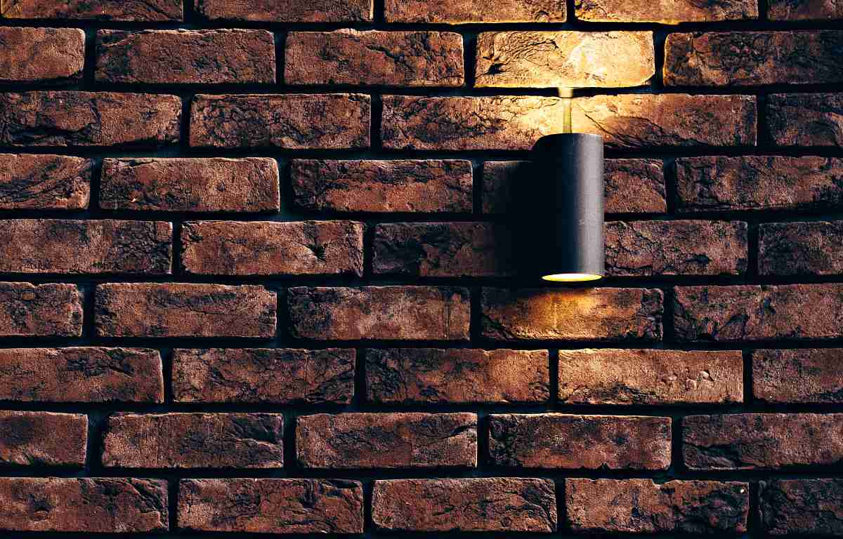

This does not have to be costly. Even shaded areas will benefit from inexpensive solar lighting.Put porch lights on a “dawn to dusk” timer and make sure your garage entrance is not shrouded in darkness. Motion lights around doorways can be startling since they come on when a person walks up to the door.

- Consider an Alarm System

I am not talking about an expensive home alarm systems and, as a matter of fact, I think advertising that you have a monitored system, whether it is true or not, simply tells the world that you have lots of goodies that need protection.
When I talk about alarm monitoring system, I am referring to a loud horn or blast that goes off when someone invades your territory. This is especially effective if you have neighbors who will also hear the alarm but even in a more remote area, the alarm will annoy and dissuade the burglars from sticking around.

These wireless motion sensors can be installed on doors to scare away a person trying to break in. Best of all, they use a battery to operate and will still work during a grid-down event.

- Add Internal Locks to Critical Storage Areas

This includes your emergency food storage area, crawl spaces, and your freezer. Many people keep their freezers in the garage, which can be one of the most vulnerable areas of your home since it is typically dark and remote sound-wise from the rest of the house.

- Secure Your Mail

In addition to minimizing identity theft, an overflowing mailbox is an open invitation to thieves who will assume you are not at home or traveling. Invest in a PO box – they are cheap.

- Keep Your Outdoor Areas Tidy

Trim shrubs that are close to the house so that strangers can not skulk behind them, waiting and watching for the best time to attack. Make certain that the perimeter of your home is clear of hiding places.

Open spaces make it easier for the neighbors to see if someone is up to mischief too.

- Be Wary of People Who Come to the Door

Whether they are strangers, delivery people, or even officers of the law, if they are unexpected, you need to be alert. These are all common tactics that precede home invasions.
Have your pepper spray handy and ask for ID. If in doubt, do not open the door. Ask for a badge or ID number and call it in. Remember, uniforms can be readily purchased online and in these days of Photoshop, fake IDs can be easily created on a home computer.

11. Add Locks to Your Gates

If you lock your gate, then you don’t have to worry about people showing up right at your door. Plus, you’ll be sure to be on high alert if there’s a knock at the door.

- Know Your Neighbors

I have said this before and will say it again: neighbors and community members who know you by name and face will be the ones that will watch your back in a crisis. You do not have to become best friends with these people – but you do need to say hi once in a while and perhaps get involved in some community activities so that they can get to know you, and you them.

13. Get a Dog
A dog is a great, really great, early warning system. Heck, my little six-pound Yorkie makes a lot of rackets if a stranger is walking around outside at night. He might not scare an intruder once he is in the house, but he certainly would give the would-be burglar reason to look elsewhere. Plus, we would know that someone who should not be here is close by if not inside our home.

14. Landscape with Inhospitable Plants



Inhospitable doesn’t mean the plants aren’t beautiful. Thorny plants like rugosa rosebushes, bougainvillea, or blackberry vines make it far more difficult to sneak around outside of windows or to climb fences. You can find a full list of inhospitable plants on the web.

15. Make Arrangements to Have Your Property Looked After When You Go Away

Have someone mow the grass when you will be gone for a week or longer and if you still have the newspaper delivered, for goodness sake, stop delivery while you are away. You can also put a light and a television on a timer so that it looks as though someone is home.

16. Disable any vehicles parked outside.

Unhook your battery cable. Thieves will move on when the vehicle doesn’t stat right away.

17. Secure Sliding Glass Doors

Before bed each night, block the track of sliding doors with a metal bar or a piece of wood. Those locks are very easy to force.

18. Secure Sidelights or Doors with Large Windows

It’s a very simple thing for a thief to break out a small window, then reach in and unlock your door from the inside. Invest in some decorative metal grid work to make this more difficult.

19. Create a Safe Area to Which You Can Retreat

In the worst case scenario, if someone breaks into your home while you are there, it’s important to have an area that you can run to until help arrives. Reinforce a bedroom door with a good quality frame, and replace the flimsy interior door with an exterior one.

Ensure you have access to an alternate means of communication inside the room (like a cell phone or landline), and a form of self-defense like a firearm or knife. You can learn more about building a safe room in your home or apartment in this article.

20. Zip Those Lips

Don’t announce on social media when you will be away and save those pictures till you get back!! Don’t announce you are not home.

